DALE MORTON’s Monster Morgue
Prosthetic Make-up & Monsters
2477 Main St. Hurricane, WV 25526
Phone: (304) 562-7503 Cell: (304) 989-8209
E-mail: dalesmonsters@aol.com

Film & theater credits
FILM & Televison
2015
-“Dr. Who” fan film trailer
(Complete MOTHMAN monster suit)
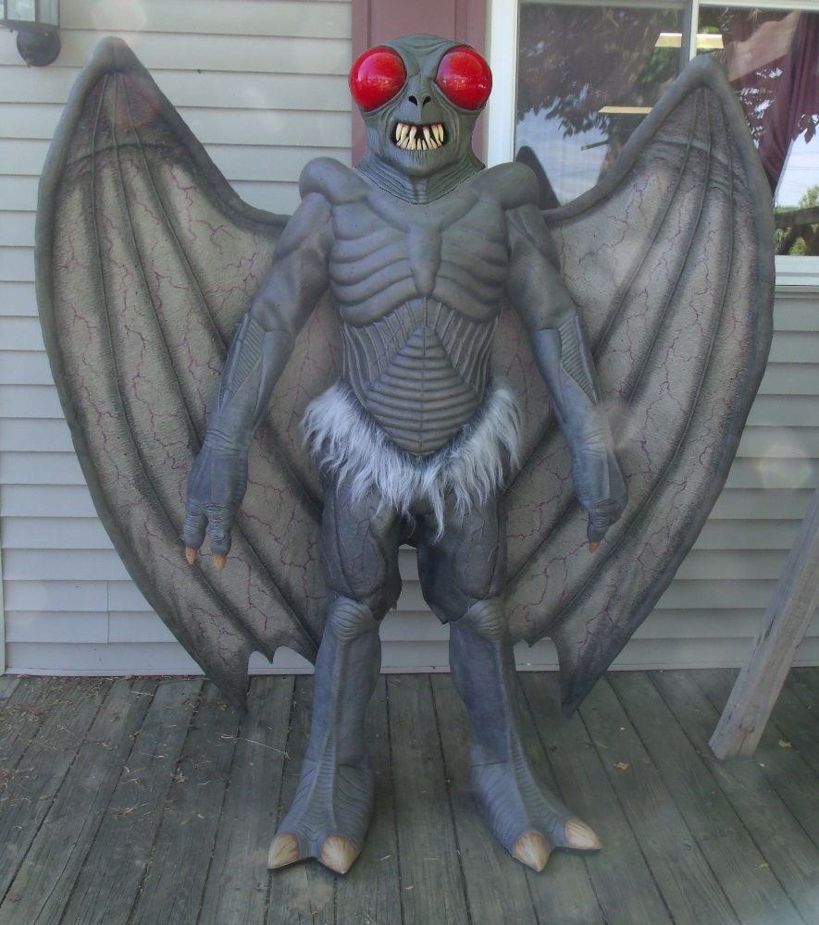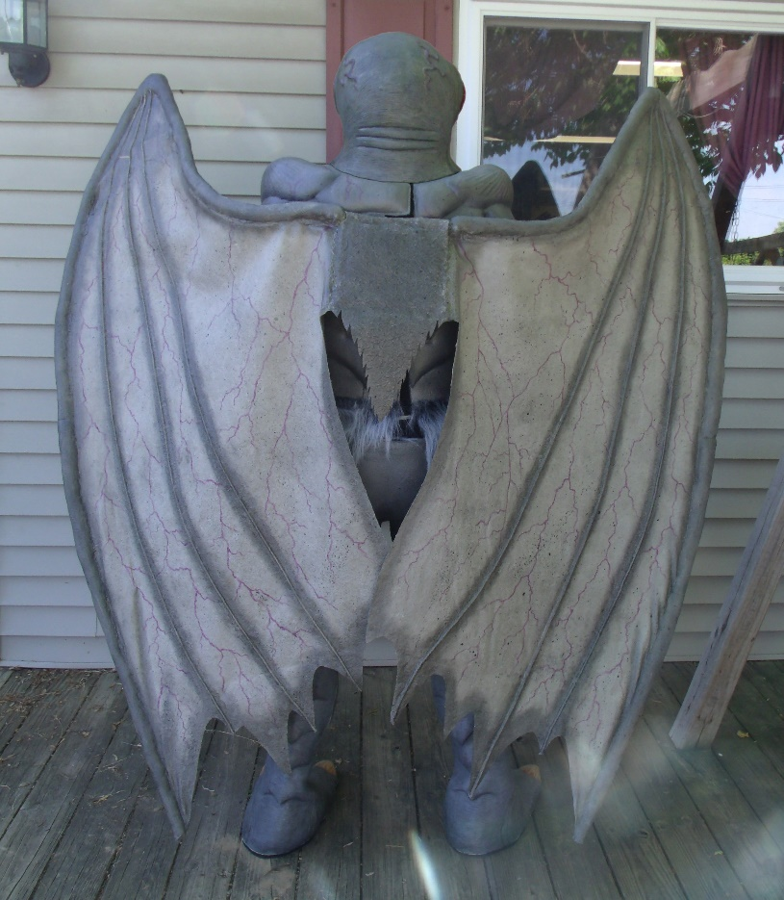

2015
-STAR TREK: NEW VOYAGES Kickstarter campaign, Retro Film Studios, Ticonderoga, New York (Creation of alien head puppet)
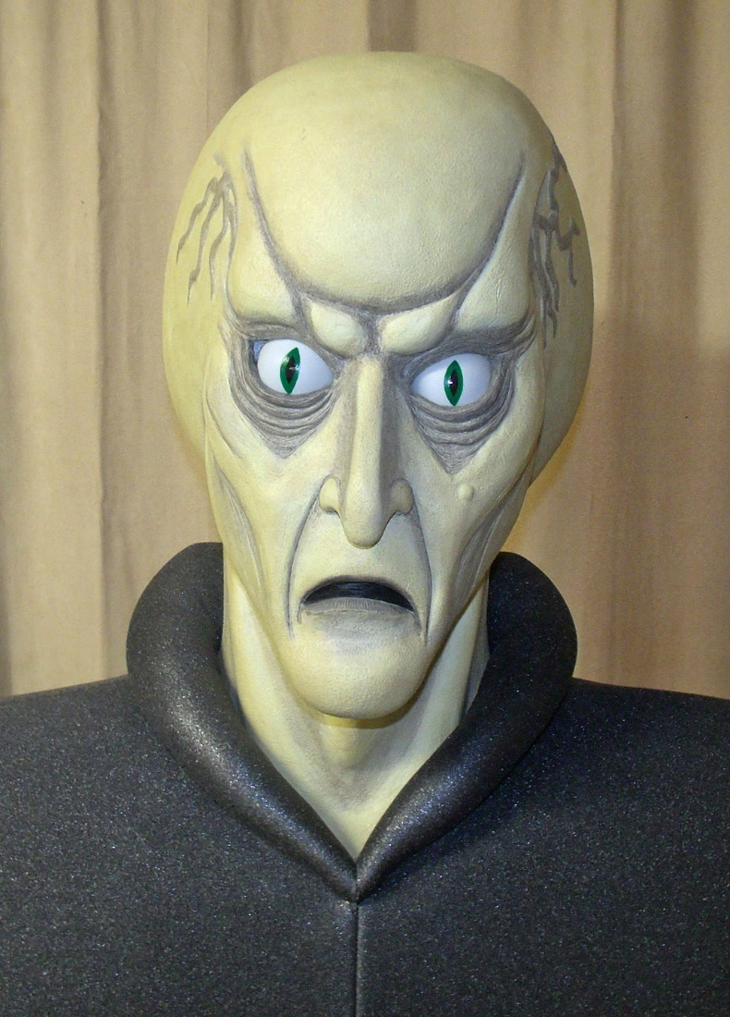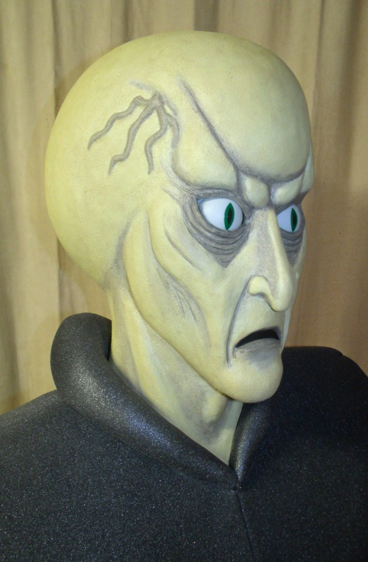
2014
-STAR TREK: NEW VOYAGES episode “Mind-Sifter”, Retro Film Studios, Ticonderoga, New York (Makeup on Klingon Commander Kor)
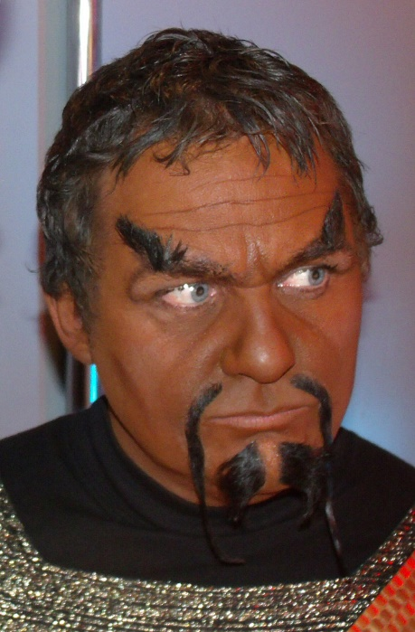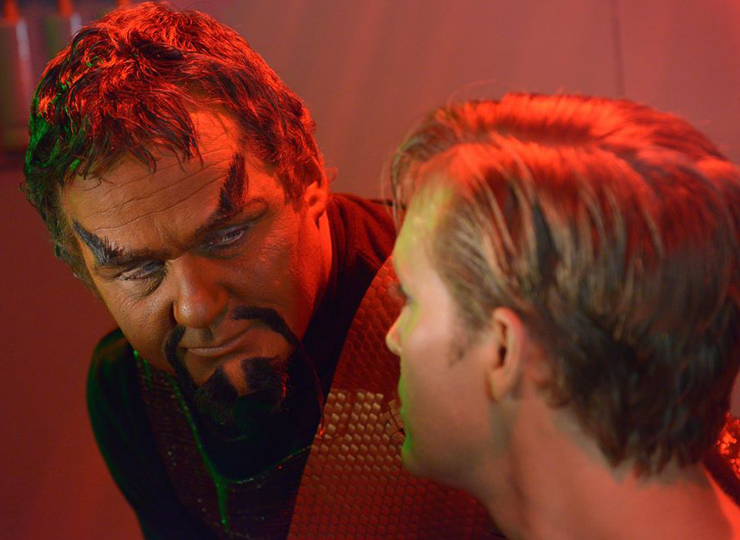

2013
-STAR TREK: NEW VOYAGES episode “The Holiest Thing”, Retro Film Studios, Ticonderoga, New York
(Creation and application of Ferengi alien prosthetic)
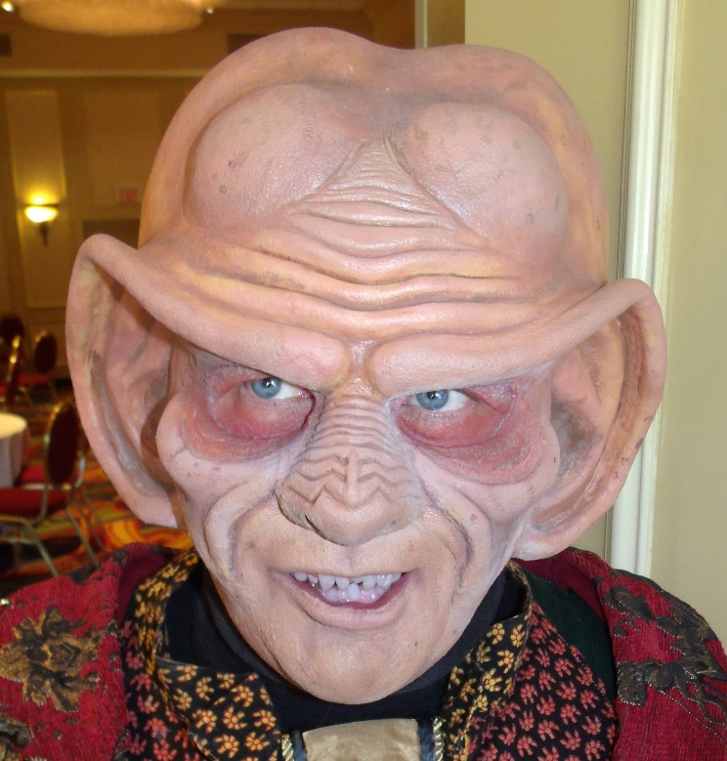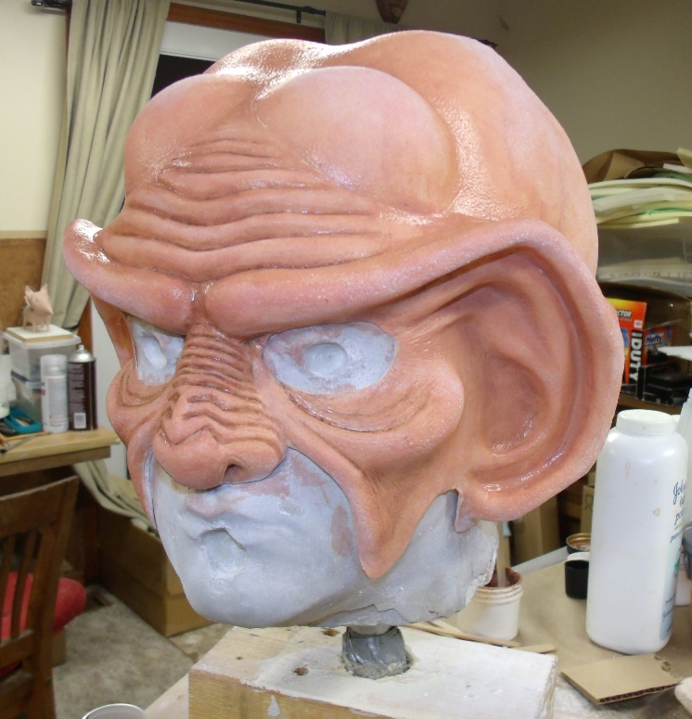
2012
“STATE O’ MASOCHIST and LADY LIBERTY” short film, Ellars Arts (Creation and application of silicone prosthetics for Elephant-Donkey monster)
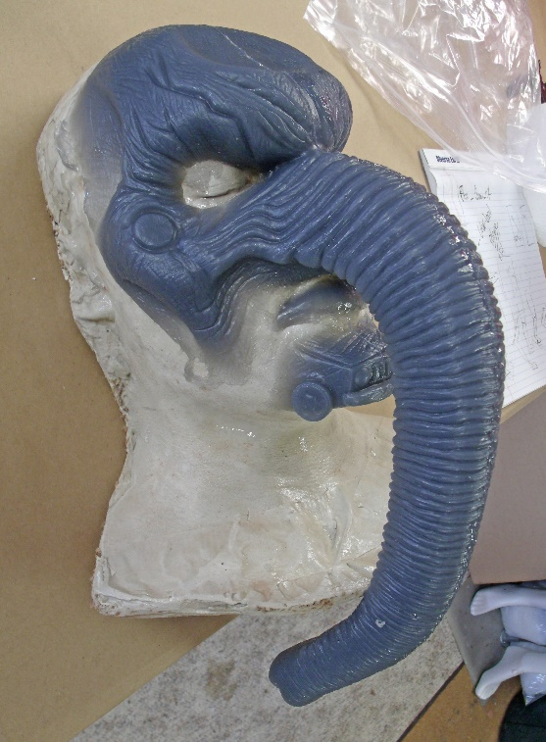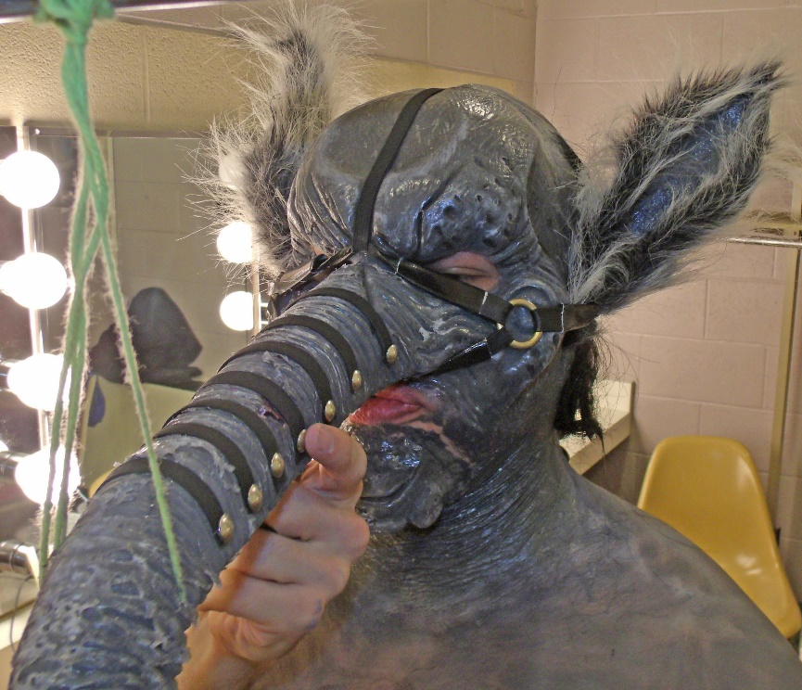
2011
“SEIN” short film, Ellars Arts
(Design & creation of full android costume involving a custom-sculpted rubber & fiberglass mask and full neoprene body suit)
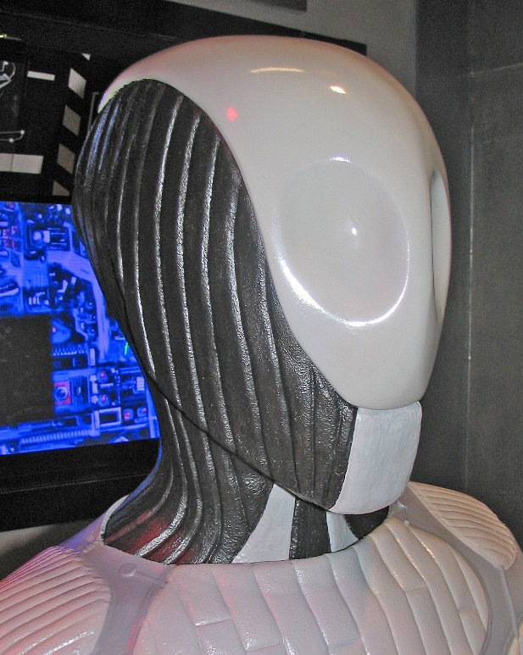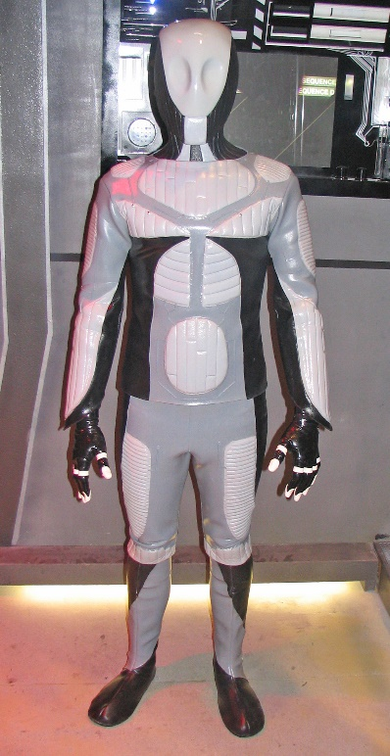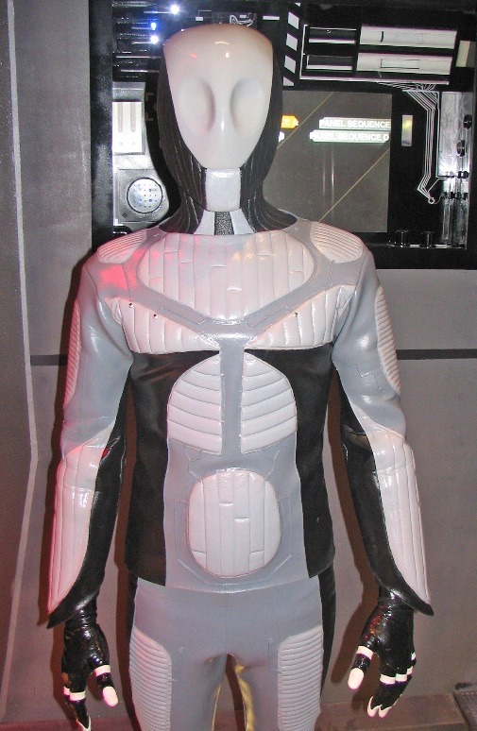
1996
“Mr. Death” series of six commercials for the W.Va. Governor’s Highway Safety Program, Image Associates
(Design & creation of mechanical Grim Reaper character with moveable eyes, mouth, brows and cable-controlled hands)
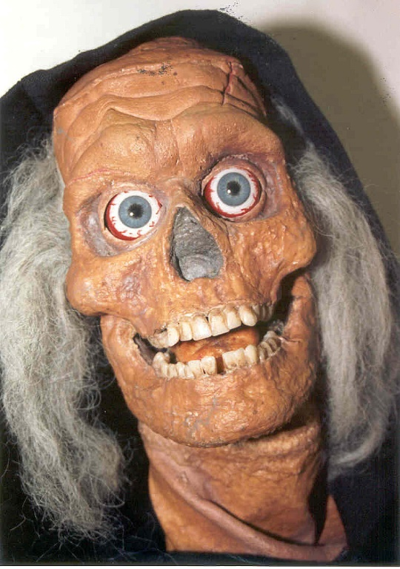

1992
“Rescue 911” episode, Arnold Shapiro Productions
(Creation of wounded bloody ankle makeup on stuntman Curtis Epper)
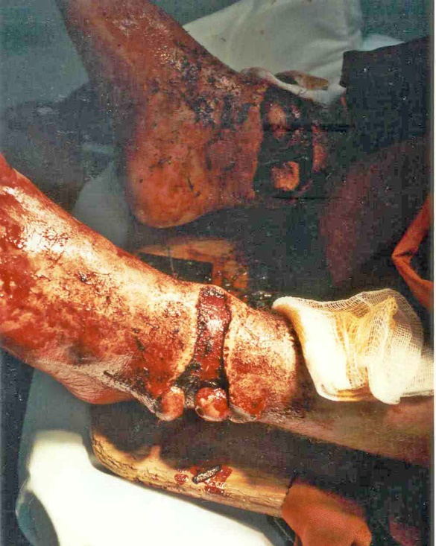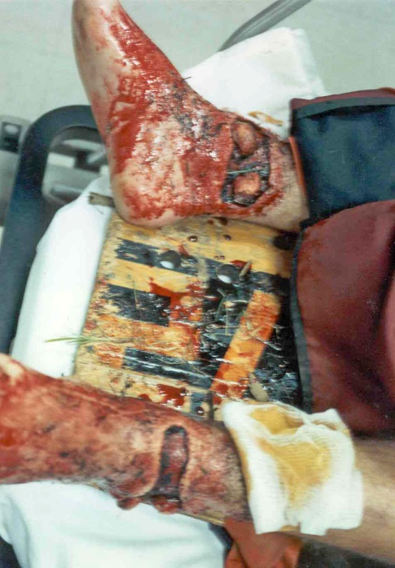
1989
“STRANGEST DREAMS: INVASION of the SPACE PREACHERS”, Troma Video/Big Pictures Productions
(Design and fabrication of four alien creature suits and one exploding human head)
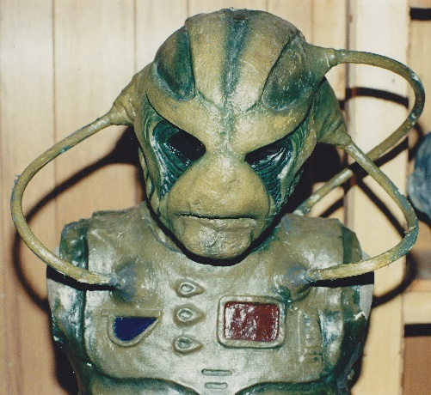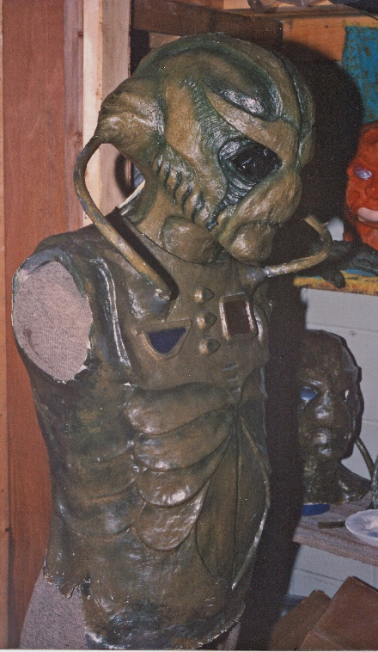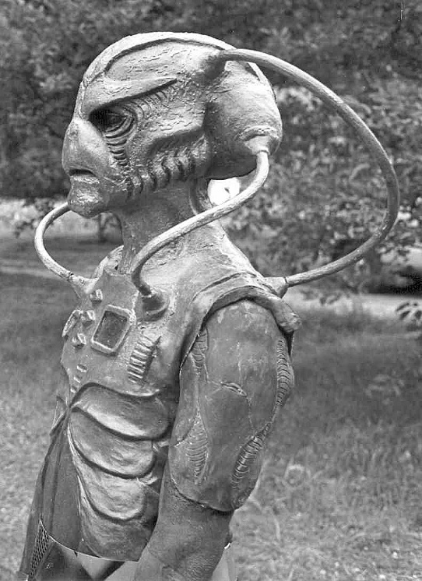
Theatrical makeup work and masks
